ClubRegistration.net eSignatures

A guide to enabling and using electronic signatures for event waivers

A direct result of the recent COVID-19 pandemic environment that requires as hands-off approach to staff and participant interaction and maintain social distancing requirements at events, ClubRegistration.net has enabled the ability to sign waivers electronically. This provides participants a contactless means to register for an event and pre-sign waivers and avoid long lines at the front-gate.

How you enable eSignatures

The process of enabling and using e-Signatures requires some interaction with your ClubRegistration.net account. Once enabled, you will have the ability to sign documents required to be reviewed and signed for each individual event. This does require a computer or some type of smart device such as a phone or tablet to work.

Signup

Log into ClubRegistration.net (https://clubregistration.net) and perform the following steps to enable eSignatures for your account:

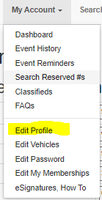a) From the navigation bar click on My Account and from the sub-menu click on Edit Profile

b) Go to the bottom of the profile page. There will be an eSignature section.

c) To enable e-Signature, click on the top radio-button to indicate that you have read the disclosure statement and agree to the use of electronic signatures on ClubRegistration.net.

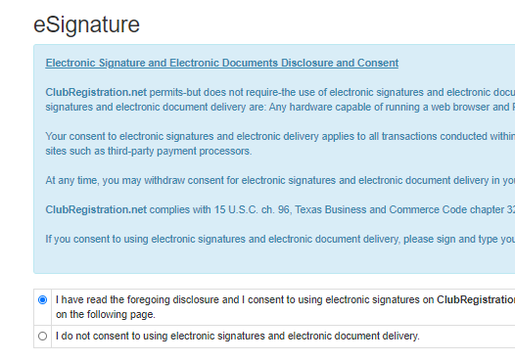

d) Click on the Save & Continue button to complete the e-Signature signup. You can now use e-waivers from the Club Registration site.

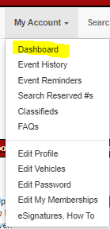Using the e-Signature for Event Waivers

Once completed with your registration go to your dashboard in clubRegistration.net. (You can always find your dashboard under My Account->Dashboard.) For each event you will find an eSignatures area that displays one or more Request buttons. Each will be tagged with a description of the document that needs to be signed.

The process of electronically signing a document is a multi-step one:

1. For the document to be signed, click on the Request button. This will email a link to the event document that requires your signature. 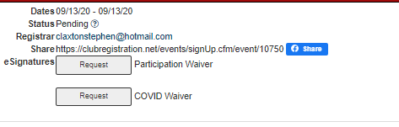

2) Look for an email message with the subject ClubReg: eSignature Request. Open that message and click on the link of the document title to open a window using your preferred browser. For Martin events there will be two separate emails. One for each waiver.

3) Read through the document content and, if you agree to its contents, click on the Continue to Sign button at the bottom to be presented with a signature box.

4) Your name should be prepopulated above the signature box. If not, enter your first and last name in the respective boxes. Enter your signature in the larger box and click on Submit Signature to complete the process. If you need to re-enter your signature, click on the Clear Signature button, and enter it again.